Malware Classification Report
Date: January 22, 2026
Analyst: Nishanth C
Tool Used: VirusTotal
Subject: Static Analysis of Known Threat
- Samply Identification
- Malware Name: WannaCry
- SHA-256 Hash: 24d004a104d4d54034dbcffc2a4b19a11f39008a575aa614ea04703480b1022c
- File Type: Win32.exe
- Classification Summary
- Verdict: Malicious ( Confirmed by 69/71 vendors)
- Family: Ransomware
- Identification Logic: The sample is universally flagged as “ Ransom:Win32/WannaCrypt “ or “ Trojan-Ransom.WannaCry “. It exhibits behaviours consistent with file encryption and network propagation.
- Behavioural Indicators
- Network Activity: The sample attempts to connect to a “kill-switch” domain. If connection fails, it proceeds to infect.
- File System: It searches for user documents and appends the extension “.wncry” after encrypting them.
- Spreading Mechanism: Utilizes the EthernalBlue exploit to spread automatically to other unpatched computers on the network.

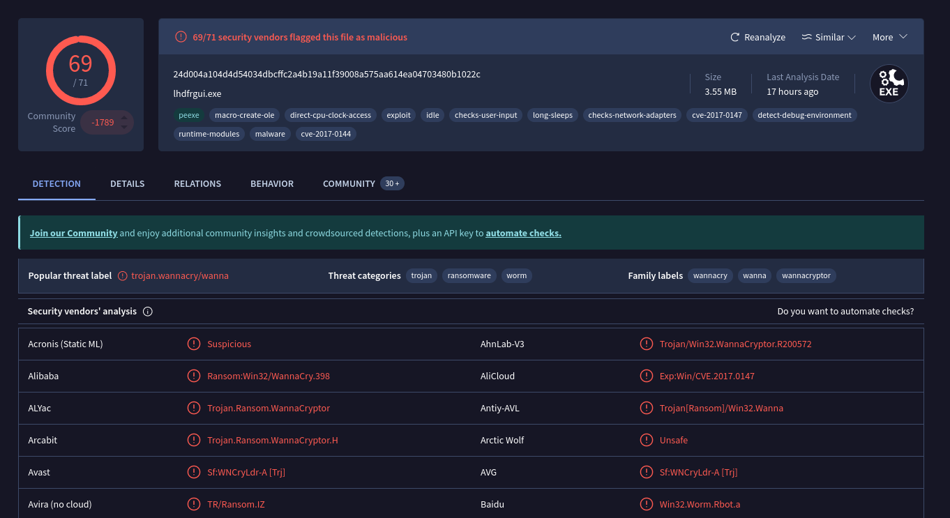
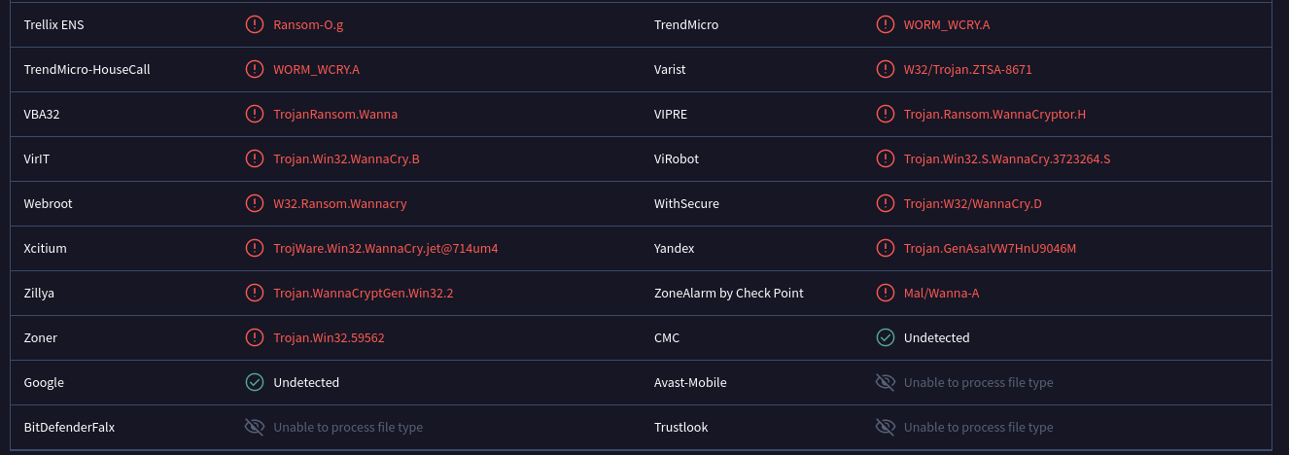

- Prevention & Mitigation
- Patch Management: Ensure Windows is updated
- Backups: Maintain offline backups. Ransomware cannot encrypt a hard drive that is unplugged.
- Network Segmentation: Disable SMBv1 and block port 445 on the external firewall.

